Project Initialization and Planning Phase
Date | 30 September 2026
Team ID | SWTID-2026-2617
Project Name | EduGenie - Google Gemini Powered Learning Assistant
Maximum Marks | 3 Marks
Define Problem Statements (Customer Problem Statement Template):
Create a problem statement to understand your customer's point of view. The Customer Problem Statement template helps you focus on what matters to create experiences people will love. A well-articulated customer problem statement allows you and your team to find the ideal solution for your customers' challenges. Throughout the process, you'll also be able to empathize with your customers, which helps you better understand how they perceive your product or service.
Example:
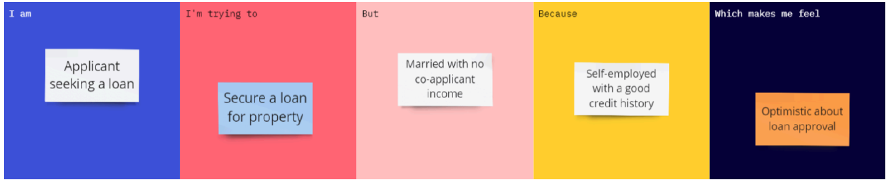
Problem Statement (PS) | I am (Customer) | I’m trying to | But | Because | Which makes me feel
PS-1 | A student preparing for exams. | Understand difficult topics, revise and practice quickly. | Textbooks and search results are long and hard to follow. | Explanations are not available in simple language at my level. | Confused and stressed.

